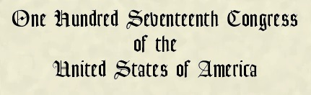
AT THE FIRST SESSION
Begun and held at the City of Washington on Sunday,
the third day of January, two thousand and twenty-one
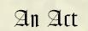
To award four congressional gold medals to the United States Capitol Police and those who protected the U.S. Capitol on January 6, 2021.
Be it enacted by the Senate and House of Representatives of the United States of America in Congress assembled,

